**Clustering Algorithms with PCA for Dimensionality Reduction**

**1. Introduction**

This report presents an analysis of clustering algorithms applied to the Wine dataset, with and without Principal Component Analysis (PCA) for dimensionality reduction.

**2. Data Preparation and PCA**

**Dataset**

The dataset used is the **Wine dataset** from Scikit-learn, which consists of 178 samples with 13 numerical features describing different properties of wine.

**Preprocessing**

* The data was standardized using **StandardScaler** to ensure uniform feature scaling.
* No missing values were detected in the dataset.
* PCA was applied to reduce the dimensionality to **2 principal components** for visualization.

**PCA Visualization**

A scatter plot of the two principal components showed clear groupings among different wine classes, indicating that PCA effectively captured variance in the dataset.

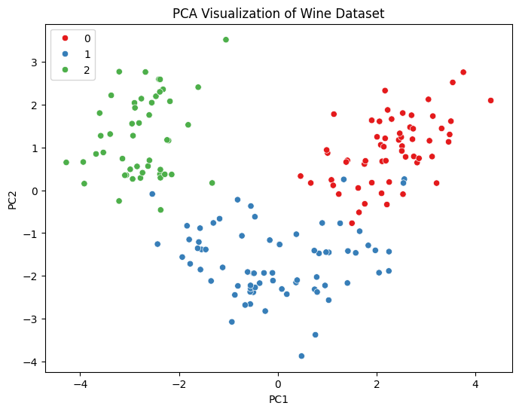

**3. Clustering Algorithm Implementation**

Two clustering techniques were implemented:

* **K-Means Clustering** (with 3 clusters, as the dataset has 3 actual classes)
* **Hierarchical Clustering** (Agglomerative approach with 3 clusters)

Each algorithm was applied to both the **original dataset** and the **PCA-transformed dataset** to compare results.

**4. Performance Evaluation**

The clustering results were evaluated using:

* **Silhouette Score** (higher is better)
* **Davies-Bouldin Index** (lower is better)

| **Clustering Method** | **Dataset** | **Silhouette Score** | **Davies-Bouldin Index** |
| --- | --- | --- | --- |
| K-Means | Original | 0.2849 | 1.3892 |
| K-Means | PCA | 0.5602 | 0.5977 |
| Hierarchical | Original | 0.2774 | 1.4186 |
| Hierarchical | PCA | 0.5591 | 0.6013 |

**5. Visualization and Insights**

* The PCA-transformed dataset allowed for **better visualization** of clustering results in a 2D space.
* Clustering performance **Increased** when using PCA-reduced data, as seen in the higher silhouette scores and lower Davies-Bouldin indices.

**6. Conclusion**

* The PCA dataset performed **better** in terms of visualizing high-dimensional data and clustering evaluation metrics.